  Special Thanks from  The Jones Family  Anytown, USA  Summer 2006 |   Special Thanks from  The Jones Family  Anytown, USA  Summer 2006
  Special Thanks from  The Jones Family  Anytown, USA  Summer 2006 |   Special Thanks from  The Jones Family  Anytown, USA  Summer 2006
  Special Thanks from  The Jones Family  Anytown, USA  Summer 2006 |   Special Thanks from  The Jones Family  Anytown, USA  Summer 2006
  Special Thanks from The Jones Family  Anytown, USA Summer 2006 | 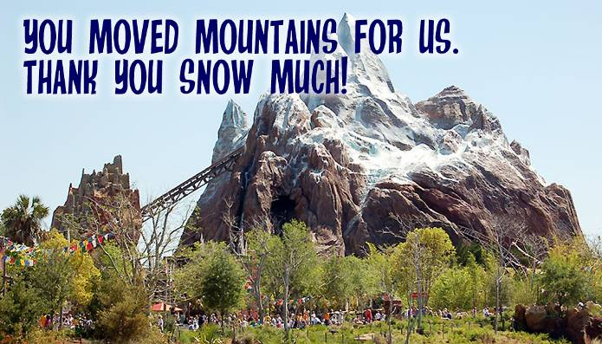  Special Thanks from  The Jones Family  Anytown, USA  Summer 2006
  Special Thanks from  The Jones Family  Anytown, USA  Summer 2006 |   Special Thanks from  The Jones Family  Anytown, USA  Summer 2006

